SATISH CHANDRA MEMORIAL SCHOOL
MID TERM EXAMINATION (2026-27)
CLASS- IV SUBJECT -EVS F.M-80

GENERAL INSTRUCTION-
1. All the questions are compulsory.
2. Question paper is divided into 5 sections.
3. Section-A (Q1-Q20) 20 Multiple Choice Questions of 1 mark each.
4. Section-B (Q21-Q26) contains Short Answer Type Questions of 2 marks each.
5. Section-C (Q27-Q33) contains Short Answer Type Questions of 3 marks each.
6. Section D (Q34-36) contains Long Answer Type Questions of 5 marks each.
7. Section E (Q37-39) contains Case Study based Questions of 4 marks each.
8. Students must write only the answers in the given answer script.
________________________________________________
SECTION -A
1. A student says, “I don't need water because I am not thirsty.” Choose the most appropriate option.
a. Thirst is the only time we need water.
b. Our body needs water regularly, even when we may not feel very thirsty.
c. Water is needed only in summer.
d. Juice can always replace water.
2. A biosphere reserve protects forest ,animals and the people who depend on natural resources . This action shows the best balance between conservation and human needs.
- Allow unlimited cutting of trees.
- Human needs are not important.
- Use natural resources carefully while protecting important habitats.
- Remove all wild animals and plants.
3. A teacher asks students to classify lemon, honey, neem,salt ginger and raw banana according to their taste. Write the ability the students are mainly developing.
a. Memorizing food names .
b. Connecting food with the shad rasa.
c. Measuring food quantity.
d. Identifying food colours.
4. In the food chain ,
Plants ------ Deer ------- Tiger
many deer are hunted by people. What could happen to the tiger population?
  - Tigers will become herbivorous.
  - Tiger population will increase.
  - Tiger population will remain same .
  - Tiger population will decrease because of less food.
5. Choose the animal which is not EXTINCT.
a.Dodo bird. b. Woolly mammoth
c.Dinosaur. d.Asian elephant
6. Among these which is an example of a temporary bridge?
a. A strong concrete bridge built for many years.
b. A railway bridge made of steel .
c. A permanent flyover.
d. A wooden bridge made for short term use.
7. The following situation shows the best use of solar energy.
a. Using solar panels to generate electricity for a house.
b. Leaving electrical appliances switched on without use.
c. Burning coal to produce sunlight.
d. Covering solar panels with cloth.
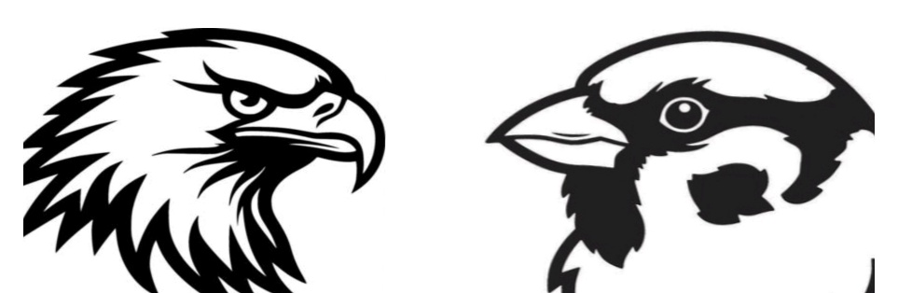
8.
A. . B.
Two birds are shown in the picture. Bird A and bird B have different beaks
Choose the correct statement.
a. Both birds must eat the same food as they have beaks.
b. Their different beaks help them eat different types of food .
c. Bird A cannot eat any food.
d. Bird B can only eat fruits.
9. A person wants to send money to a relative living in another city. Which service he could use?
a.Money order. b. Parcel service
c.Post card. d.Newspaper
10. Neighbourhood has no clean public places. The people living there should do this –
a. Throw waste anywhere.
b. Stop using the places.
c. Work together to keep them clean.
d. Damage the public property.
11. This historical place is shown on the other side of 100 rupees Indian currency.
a. Red Fort b. Rani ka Vav
c. India Gate d. Gateway of India
12. A cockroach is moving in a dark room and keep moving its antennae. Why does it do this?
a. To dance in the dark.
b. To sense objects and changes around it.
c. To make its body warm.
d. To help it fly.
13.Meena wants to include more protective foods in her lunch . Choose the best option.
a. Chips and soft drinks
b. Rice and butter
c. Carrot and orange
d. Bread and jam
14. If a duck had no webbed feet which activity would become difficult?
a.Swimming b. Sleeping
c. Flying d. Eating
15. This part of an onion, often thrown in the dustbin, can be boiled in water to get a lovely orange-brown dye.
a.The green stem. b. The juicy middle rings.
c.The dry outer skin. d. The root base.
16.
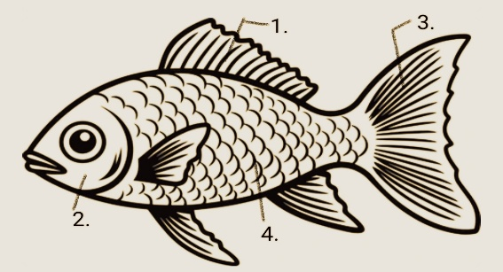
Observe the fish diagram and choose the correct option.
a. 1.Gill flap 2.Fin 3.Tail 4. Scale
b. 1.Fin 2. Gill flap 3.Tail 4.Scale
c. 1. Fin 2.Gill flap 3. Scale 4. Tail
d. 1. Tail 2. Fin 3. Scale 4. Gill flap
17. Assertion (A): Petals are usually brightly coloured and have a nice smell.
Reason (R): Bright colours and sweet smell help attract bees and butterflies to the flower .
a.Both A and R are true and R is the correct explanation of A
b.Both A and R are true but R is not the correct explanation of A
c.A is true but R is false
d. A is false but R is true
18. Assertion (A): Dodo birds can still be found flying in modern forests.
Reason (R):The dodo birds is an extinct bird that died out long ago.
a.Both A and R are true and R is the correct explanation of A
b.Both A and R are true but R is not the correct explanation of A
c.A is true but R is false
d. A is false but R is true
19. Assertion (A): Our body needs vitamins and minerals to fight diseases.
Reason (R) : Vitamins and minerals are called energy giving foods.
a.Both A and R are true and R is the correct explanation of A
b.Both A and R are true but R is not the correct explanation of A
c.A is true but R is false
d. A is false but R is true
20.Assertion (A): Many tribal communities worship trees, rivers and mountains.
Reason (R): They believe that nature provides them with everything they need to live and should be respected.
a.Both A and R are true and R is the correct explanation of A
b.Both A and R are true but R is not the correct explanation of A
c.A is true but R is false
d. A is false but R is true

SECTION -B
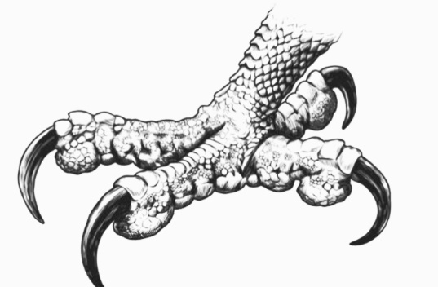
21. Observe the given picture and write the name of the specialized claws and also name the bird that have these type of claws.
22. Draw a food chain using Butterfly, Snake, Plant, Frog.
With whom the food chain starts?
23. A packet of chips looks attractive, but a bowl of fruits is healthier . Explain why.
24. Write one point of similarity and one point of difference between boiling and steaming – methods of cooking .
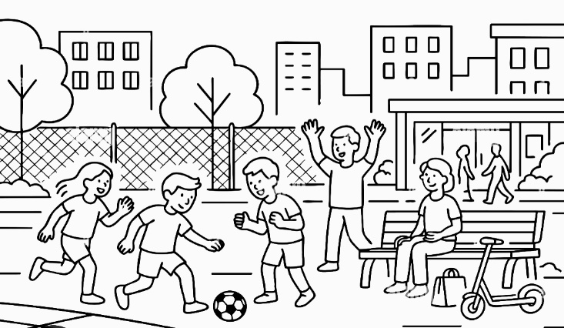
25.
Different people use this community place for different purposes.
Mention any two ways in which this place is useful to the community.
26. Draw a solar cooker and write one benefit of using it.
SECTION-C
27. i) Draw a leaf showing reticulate venation. Label the midrib. (2)
ii) Name a plant showing parallel venation. (1)

28. i) Write 2 ways how we should care for plants and animals. (2)
ii) Name the tree worshipped during Vat Purnima. (1)

29. Birds have beaks. Write 3 ways how birds use their beaks. (3)

30. Write about energy giving foods.Show two examples by drawing .(1+2)

31. i) Differentiate between afforestation and deforestation. (2)
ii) Draw reforestation.(1)

32. Name two medicinal plants and write one use of each. (3)

33.i) Write 1 use of natural dye. (1)
ii) Write 2 ways how tribal people live in perfect harmony with nature. (2)
SECTION -D
34. i) Mention 3 reasons why we should eat healthy foods. (3)
ii) Write the 6 tastes of shad rasa . (2)

35. Draw a flower and label any 4 parts of your choice. (1+4)

36. Show the following in the given map of India-(5)
i) Colour the state blue which is famous for Gond painting.
ii) Mark Gir National Park (with green colour)
iii) Mark Great Nicobar Biosphere Reserve ( with orange colour)
iv) Colour the state yellow where Chhena-poda is famous.
v) Colour the state pink where Magh Bihu is famous.
SECTION -E
37. Case study -1
A bird sanctuary is a protected place where birds can live, feed, nest and raise their young safely. It provides birds with trees, water and food. Many migratory birds also visit bird sanctuaries during different seasons. People should keep these places clean and avoid disturbing the birds. Bird sanctuaries help protect birds and conserve nature.

- A group of students visits a biosphere reserve. Their teacher asks them not to throw plastic waste. Why?
(2)

- Aman sees a rare animal inside a biosphere reserve. He wants to take it home as a pet. What should he do? (1)
A. Catch it secretly
B. Leave it in its natural habitat
C. Sell it
D. Feed it packaged food

- A company plans to cut down a large area of forest inside a biosphere reserve to build factories. Why should this be stopped?(1)
A. It may destroy habitats.
B. It will increase rainfall.
C. It will provide more food for animals.
D. It will make the forest larger.

- Case Study-2
A food festival is a special event where people prepare, display and enjoy different kinds of food. It may include traditional dishes from different regions and cultures. People can learn about new foods, ingredients and cooking methods. Food festivals bring people together and help us appreciate the rich variety of food in our country.
- Rahul eats chips and biscuits whenever he feels hungry. What should Rahul choose to eat more often? (1)
- Sita's doctor advises her to eat foods rich in proteins.Which foods can she eat? Name 2 of them. (2)

- Mita has to walk a long distance to school. Her mother gives her a banana and sandwich for breakfast. Which food group mainly gives her energy? (1)
39.Case study-3
Joy Nagar neighbourhood has two important places side-by-side: the local bank and the community post office.
Last week, ten-year-old Meena went with her grandfather to the post office to buy stamps and mail a letter to her aunt. Next door at the bank, Meena's mother was opening a savings account to deposit money safely. Suddenly, the power went out in both buildings, stopping the computers. Instead of panicking, the bank manager and the postal officer worked together, sharing a backup portable generator so citizens could finish their urgent work securely.
i) Meena visited the community post office with her grandfather -
a..To withdraw a large amount of cash
b. To buy stamps and mail a letter to her aunt
c. To buy fresh fruits and vegetables
d.To get a health check -up from a doctor

ii) To withdraw or deposit money in a bank a person should have –
a.Book
b.Card
c. Account
d.Name
iii) It is super helpful to use mobile banking from home because -
a.You don't have to wait in long lines at the physical bank.
b.It makes your phone turn into a real robot toy.
c. It lets you eat ice cream through the screen.
d.It does your school homework for you.
iv). We all live in neighbourhood . Who is responsible to keep it clean?
a.The government
b.Children of the neighborhood
c.Everyone in the neighborhood
d. Elders of the neighborhood

